Strymon Editors User Guide

Ritchie Whytock 02/04/2014, applies to V 0.2.0.3 of the Strymon Editors application

# Background

The Strymon Editor is a Microsoft .Net WPF User Interface to allow offline editing of presets created in the 3 ‘big’ guitar effects pedals from [Strymon](http://www.strymon.net/), the [Timeline](http://www.strymon.net/timeline/), the [Mobius](http://www.strymon.net/mobius/) and the [BigSky](http://www.strymon.net/bigsky/).

This guide assumes that anyone using the editor has a good understanding of how these pedals work.

# Main User Interface

When starting up the Editor, the user will find a simple main screen, with the Strymon logo and a menu, and a status bar. By default this screen will start maximised.

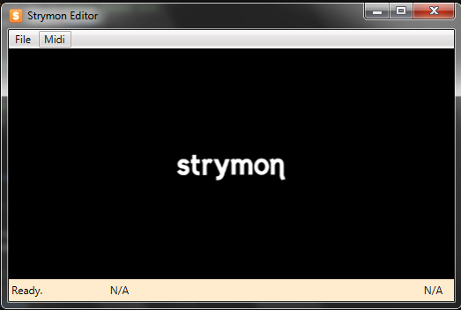

*Figure 1 – The Main Window*

The file menu will allow the user to create new ‘from scratch’ presets – which are useful simply to mess around and explore the different machines for each pedal. Additionally, the menu has options for loading an existing preset – either a .syx file that has been fetched from the pedal itself using the Strymon Librarian, or an xml format that the Editor itself uses to save presets in.

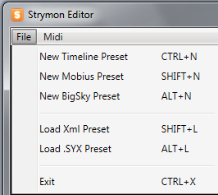

*Figure 2 – The Main Menu*

The options are as follows:-

* New BigSky Preset
* New Mobius Preset
* New Timeline Preset
  + All 3 of these options will simply spawn a new editor window for the selected pedal, with some defaults selected (currently all minmum)
* Load Xml Preset
  + The user can browse to an xml preset for any pedal and the respective editor will spawn. If the preset is not valid, the user will be notified, and no editor will open.
* Load .SYX Preset
  + The user can browse to a SYX preset downloaded from a pedal or the internet for any pedal and the respective editor will spawn. If the preset is not valid, the user will be notified, and no editor will open.
* Exit
  + This will close the Editor.

***NB : All menu options clearly show key command shortcuts where available.***

The MIDI menu opens a setup / configuration panel to setupor change the MIDI setup see the MIDI Support section for more details

# ‘Pedal’ Interface

The editor window is a ‘modal’ dialog window, allowing a user to make changes to the preset.

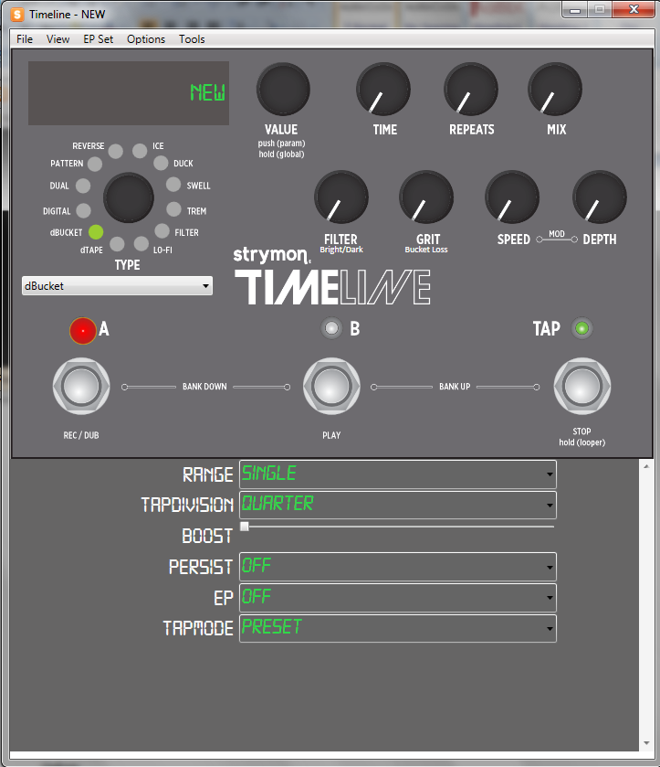

*Figure 3 – Pedal Interface (Timeline)*

This interface is divided into 2 panels – the top panel is a representation of the pedal itself, with mostly similar interactions. The lower panel, that obviously does not exist in the physical pedal, shows the parameters that can only be edited via the parameter menu that is accessed by pressing the Value encoder on the pedal.

# Interactions

## Pots

Each ‘pot’ can be manipulated in a number of ways:-

1. Using the mouse Scroll-Wheel when hovered over the pot; ***scroll up to increase***, ***scroll down to decrease***
2. Using the mouse to grab the pot and dragging ***left to decrease***, and ***right to increase*** the value.
3. Navigating to the pot using the TAB key, then using ***PageUp to increase*** or ***PageDown to decrase*** the value.
4. Changing the parameters on the physical pedal, depending on which ‘Sync Mode’ is active (see TODO)

Pressing CTRL modifier will give a finer degree of control over modification for options 1,2 and 3.

When TABbing to controls, focus will be highlighted by a gold dotted border.

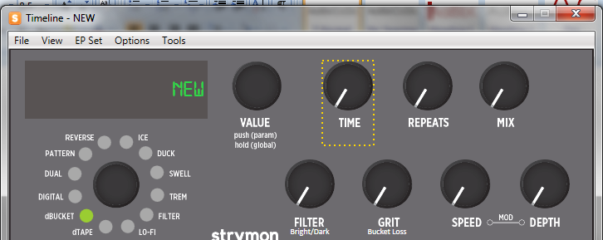

*Figure 4 – Navigation Focus*

## Machines

Machines can be selected / changed in one of two ways – simply by choosing from the drop-down box, or clicking on the ‘led’ light for the respective control.

## ‘Hidden’ Parameters

The additional parameters are either simple drop down lists, or slider controls depending on the parameter.

## View Menu

The View menu currently has a single menu option to allow the display to show BPM instead of milliseconds or Hz (Mobius)

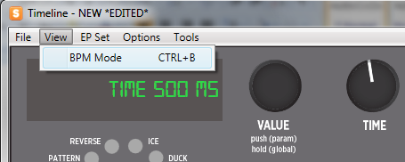

*Figure 5 – BPM Mode not set – milliseconds displayed*

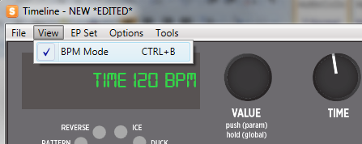

*Figure 6 – BMP Mode set – BPM displayed.*

***NB :- The BPMMode setting is saved to user preferences on close of the application, so if you prefer working in BPM then it will be always set that way.***

***Also, although BigSky has no actual BPM mode in the pedal, the option is still available in the Editor.***

## Context Actions

Two options can be accessed by right clicking the LCD Display

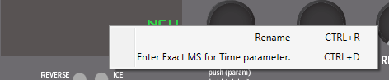

*Figure 7 –LCD Context Menu*

These are:-

1. Rename
2. Direct ‘Fine Parameter’ entry

Both these options will bring up a dialog for entering the respective value, and these can directly be executed by pressing the key command shortcuts.

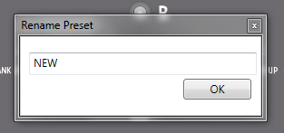

*Figure 9 – Rename Dialog*

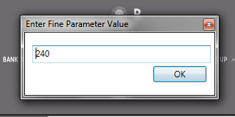

*Figure 10 –Fine Parameter Direct Entry.*

***NB:- The Fine Parameter entry expects values to be entered in based on the status of the BPMMode; if BPM mode is selected then direct entry is in BPM, otherwise it is in milliseconds (or Hertz for Mobius).***

# Loading & Saving Presets

Presets can be loaded using the File Menu within the current editor in addition to via the main window menu, and follows exactly the same process.

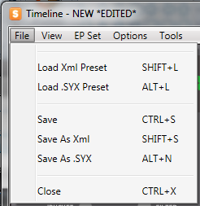

*Figure 11 – Editor File Menu*

Within the editor there is also the option to save the current preset – there are 3 options:-

* Save
* Save As Xml
* Save as .SYX

These follow the standard approach to saving as most applications – for Save As (or Save where the preset has not originated from the file system), a file dialog will appear prompting the user to save.

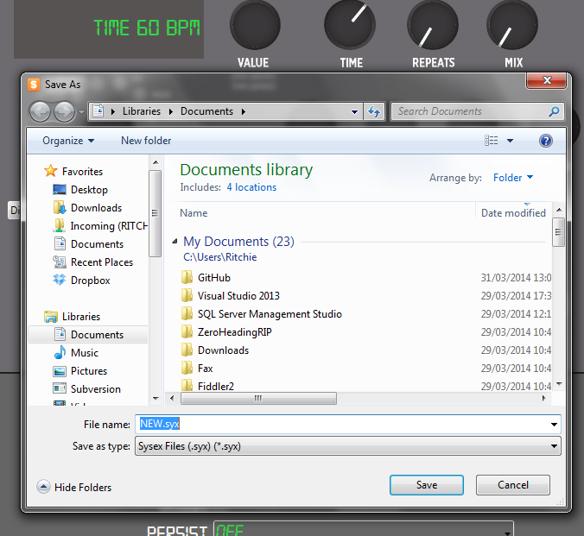

*Figure 12 – Save As Dialog (.Syx)*

If the preset was loaded from the file system, or has been saved to a file already, the Save option will overwrite that file, as per normal for applications.

The file dialog will default to the name of the preset.

## Edited Presets and Exiting

Whenever anything is changed in the active preset after it is loaded from it’s initial state, the editor window will indicate that it is ‘edited’. If it reverts back to the original state, or a new preset is loaded, the ‘edited’ flag will dissapear.

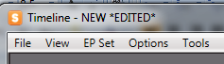

*Figure 13 - Edited Preset Indicator*

If the current preset is in an Edited state, and the Editor is closed, a confirmation dialog will appear

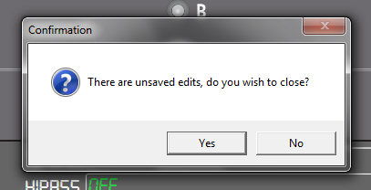

*Figure 14 – Unsaved Edits Dialog*

This dialog will allow the user to select No, giving to opportunity to save the edits.

# Mobius & BigSky Dynamic Parameters

Figure 15 & 16 should illustrate how the PARAM 1 and PARAM 2 pots can be assigned – simply drag the name of the parameter to be assigned and drop it on the pot. Now the pot and the drop down will be in sync. Additionally the UI clearly shows what parameter is currently assigned in smaller text underneath.

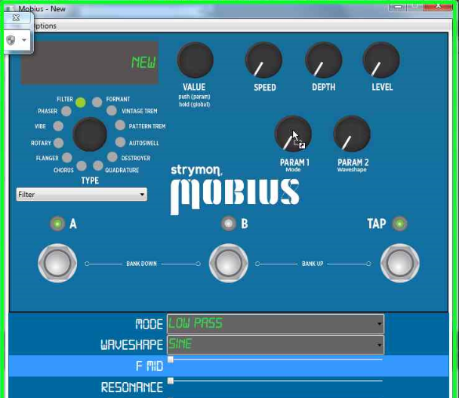

*Figure 15 – Drag and Drop F-Mid parameter to PARAM 1 pot*

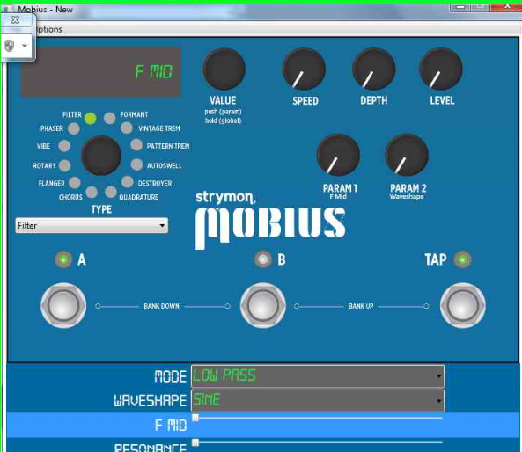

*Figure 16 – F-Mid now assigned to PARAM 1 pot*

Note in figure 7 above, after the drop operation, PARAM 1 now has the txt F-Mid underneath.

## EP Set

In all 3 pedals, there is the function to control an Expression Pedal. The Editor has some specific support for this, found under the EP Set menu.

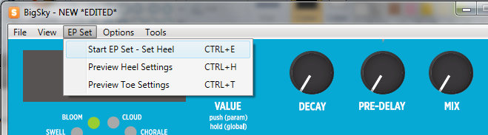

*Figure 17 – EP Set Menu*

The 3 menu commands are as follows:-

1. EP Set ‘Wizard’ Option, consisting of the steps
   1. Start (Set Heel)
   2. Step 2 (Set Toe)
   3. End
2. Preview Heel pot settings
3. Preview Toe pot settings

**EP Set ‘Wizard’**

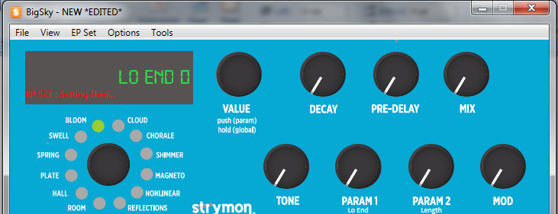

*Figure 18 – EP Set Wizard Start/Step 1 – Setting Heel*

Once the Start menu option is selected (or the keyboard shortcut of CTRL+E is pressed), the LCD display will update to show the legend ‘EP SET : Setting Heel...’ clearly in red text. At this point, the user can manipulate all the pots to whatever state is required for the heel setting. The menu option txt will read a bit different now to trigger the next step.

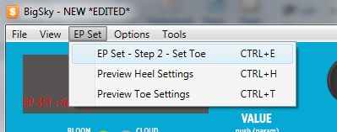

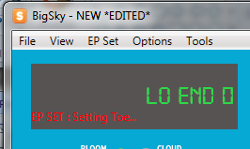

*Figure 19 & 20 – EP Set Wizard Step 2 – Set Toe, and resulting LCD Display*

Once the Set To option is selected (or CTRL+E is pressed), the LCD Display EP Set legend will change to indicate that it is now the Toe that is being set.

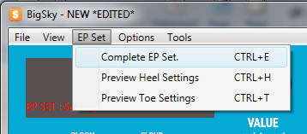

*Figure 21 – EP Set Wizard Complete step.*

Once the final step is selected (or CTRL+E pressed), the red EP Set txt will disappear and all the pots will revert back to the positions they have for the actual preset.

EP Set Preview

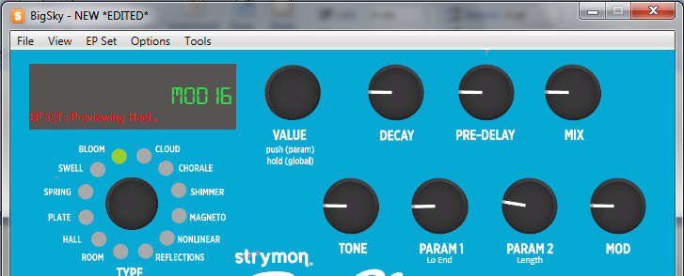

*Figure 22 – EP Set Heel Preview*

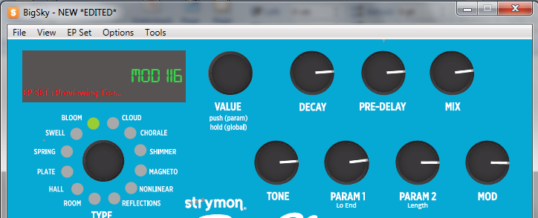

*Figure 23 – EP Set Toe Preview*

Figure 22 & 23 show the preview menu options – these are ‘toggle’ options in the menu, and will display what the currently stored heel and toe settings are for the active preset – this is useful as it is somthing that can’t be done on the physical pedal.

***NB:- The EPSet parameter DOES NOT HAVE MIDI CC SUPPORT. This means that to change this parameter on the pedal, the user can either ‘push’ a perset from the editor to the edit buffer or another preset location, or manually sync the preset by changing the parameter on the pedal.***

# MIDI Support

In the main window, clicking the MIDI menu will open the following panel:-

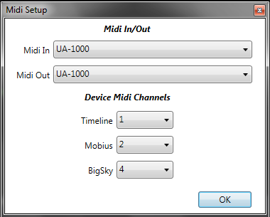

*Figure 24 – MIDI Setup Panel*

Select the correct MIDI in and Out Device, and specify channels for each of the supported pedals.

***NB:- These are saved to user preferences and will only need set if something changes.***

**Status Bar**

When opening the editor, the application will attempt to connect to MIDI and determine what pedals are connected (currently it appears that a maximum of 2 pedals can be connected at one time – I have a query with Strymon on this).

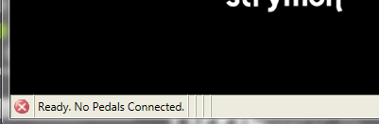

Figure 25 – No MIDI Connectivity Status Bar

If Midi connection is not made any of the 3 pedals, the status bar will show a red x icon to indicate that there is no MIDI connectivity. Additionally, each editor will display a RED ‘led’ next to the A switch to indicate that there is no MIDI connectivity.

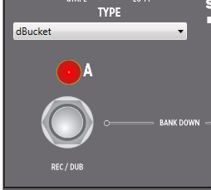

*Figure 26 – Timeline Editor with no Timeline connectivity.*

If the RED light is absent and the normal green LED image appears, the pedal is connected and can be used in the various ‘Sync’ modes.

When MIDI Connectivity is established, the status bar will update with agreen ‘tick’ icon, showing the pedal that is connected and also will display a progress bar as it starts fetching the presets from the pedal.

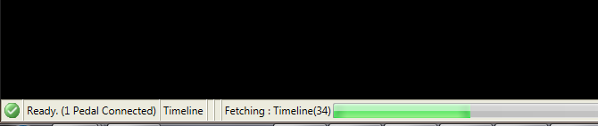

*Figure 27 – Timeline Connected, and fetching presets.*

The presets are fetched in a background thread, and editors can be loaded while the presets are fetching. However, to keep the SysEx messaging system stable, a number of functions will be disabled in the various Sync modes until the presets are loaded.

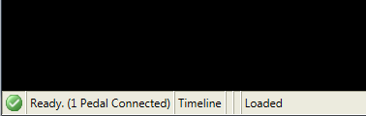

*Figure 28 – Timline Connected and all presets fetched.*

## Sync Modes and Real-Time Connectivity

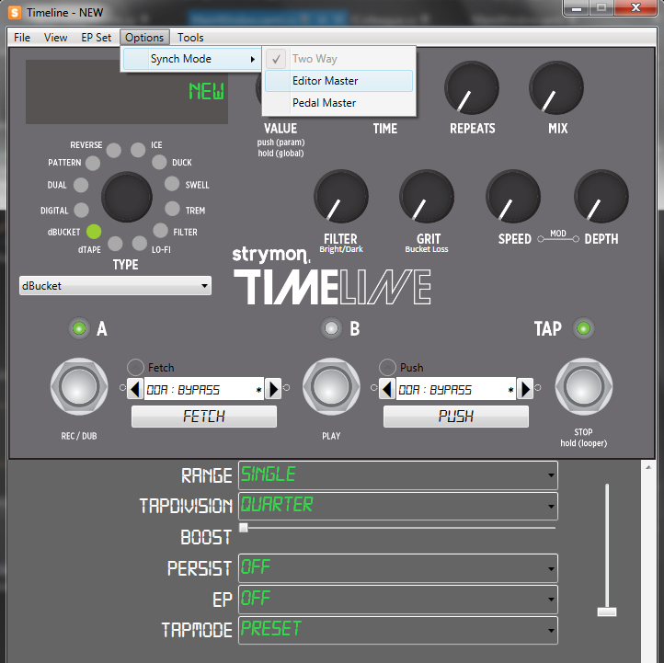

*Figure 29 –Fully Connected Timeline Editor with the default Sync Mode of ‘TwoWay’ selected.*

**Sync Modes**

There are three ‘Sync’ modes, that offer different degrees of control over how Control Change and Program Change messages are handled, explained as follows:-

1. Two Way
   1. The default mode, where the Editor and the Pedal will attempt to maintain full sync by processing CC and PC messages in both directions. E.g. make a change on the editor, and it will be reflected in the pedal. Make a change on the pedal, and it will be reflected in the Editor.
2. Editor Master.
   1. In this mode the pedal will respond to CC and PC changes issued by the Editor, but the Editor will ignore any changes made manually on the pedal, including changes of preset.
3. Pedal Master
   1. In this mode, the Editor will be dumb, and not issue any CC changes itself. This mode is useful for testing to ensure the editor does not make any alterations to the pedal.#

**Pedal Preset ‘Browsing’**

Referring to Figure 29, when connected, the ‘Fetch’ and ‘Push’ collapsible controls will be available, allowing audition / view of the presets on the currently connected pedal, either via the left/right arrow buttons, or using the mouse scroll-wheel for quicker navigation. Once the desired preset has been selected the 2 controls as follows:-

* Press the Fetch button to pull the ‘fetch’ preset into the Editor.
* Press the Push button to send the active editor prset to the ‘push’ preset lcoation on the pedal.

***NOTE – Pushing a preset to the pedal will OVERWRITE whatever preset is currently stored there!! Due to this, a dialog will prompt for confirmation***

***NB:- Similar to exiting the app, if the current preset has unsaved edits, a dialog will prompt for confirmation on a fetch.***

***As noted previously, if the editor is opened while presets are being bulk-fetched after start up, the Fetch and Push buttons will be disabled until the bulk fetch is completed.***

## Tools – Pedal Backup

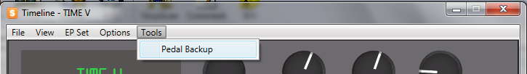

If connectivity has been established and all the presets were loaded from the pedal at start up, the following menu is available, allowing all 200 (or 300 in the case of the BigSky) presets to be saved in a single .syx file.

***NB – this backup will only save the state of the presets after the last bulk fetch has been completed; any saves applied on the physical pedal will not be represented. However, a reload of all presets can be forced as a workaround, by opening the MIDI Setup panel anc clicking OK, to refresh the MIDI setup, which will retrigger the bulk fetch.***

***Currently this ‘bulk’ .syx can only be restored to the pedal via the Strymon Librarian – a function to restore will be added in a later version.***

## Misc MIDI Suppport

* Virtual Expression Pedal – sends Expression CC and will emulate an expression pedal. NB the pedal will only respond to changes if the EP parameter is set to ON

## Key Commands for other MIDI Actions

**Edit Buffer**

CTRL+F = Fetch the curren Edit Buffer of the pedal to the Editor

CTRL+P = Push the active preset in the Editor to the pedal’s Edit Buffer (this does not overwrite any presets and requires a physical save using the pedal)

**Timeline Looper**

F1 = Lopper Record

F2 = Looper Stop

F3 = Looper Play

F4 = Looper Undo

F5 = Looper Redo

F6 = Looper Reverse

F7 = Looper Half/Full Speed

F8 = Looper Pre / Post

**Timeline & BigSky**

CTRL+I (i) – toggle Infinite / Hold

# Known Issues & Possible Improvements

No major known issues at the time of writing, however the following scenarios have not been tested much and may cause issues:-

* Multiple pedals connected at one time via MIDI Thru does not work, at least not on the development MIDI interface. The Editor should only be used with a single pedal connected to the MIDI interface.
* With the TwoWay and PedalMaster sync modes, it is possible to ‘confuse’ the editor by moving multiple pots at the same time. I am investigating this.
* Key Commands for Fetch Current and Push to Current (CTRL

**Improvements**

* Add **Restore from Backup** to load a .syx saved previously and reload the whole pedal. Similar to Librarian functionality.
* Provide menu support for various KeyCommands that currently have no menu
  + It’s very quick to add key commands directly, menus take a bit more time :)
* Better documentation!!

**Issues and Suggestions, Email** [*ritchieboy@blueyonder.co.uk*](mailto:ritchieboy@blueyonder.co.uk)